Coronavirus impact on industry – DCMS Survey 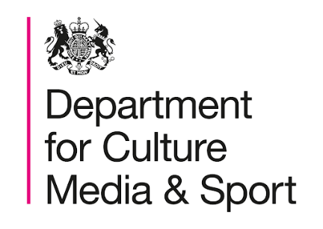

The Department for Digital, Culture, Media and Sport (DCMS) invites you to take part in a survey being conducted to understand the impact of the Coronavirus outbreak on organisations in the digital, creative, culture, media, sport, gambling, telecoms, and tourism sectors and their engagement with the available government interventions.
This survey has been commissioned by DCMS to better understand the needs of its stakeholders. Your answer will remain anonymous and will be used to inform DCMS’ preparedness efforts.
We encourage organisations in the digital, creative, culture, media, sport, gambling, telecoms, and tourism sectors to respond. The survey should take around 10-20 minutes. The deadline for responses to the survey will be at 23:59 GMT on 15/05/2020.
When asked in what industry your organisation operates, please select ‘Other’ and specify ‘Events’ unless your primary activity is covered elsewhere in the listing.
Please follow the link below to begin submitting your response:
DCMS Business Impacts of Coronavirus Survey

